**Project Plan**

PRJ-TP005, Ver 3.0

Customer: ATT

Project Code: 5494

Project Name: Digital_SQEM_Consumer_T&M

**Version History**

|  |  |  |  |  |  |
| --- | --- | --- | --- | --- | --- |
| **Version No** | **Date** | **Prepared By** | **Reviewed By** | **Approved By** | **Reason and Nature of Change** |
| 0.1 | 09/27/2016 | Saroj Nayak |  |  | Initial draft (for converting to TechM managed project) |
| 1.0 | 12/13/2016 | Saroj Nayak | Sandeep Malik | Ravindra Joshi | First Baseline Version |
| 1.1 | 03/15/2017 | Kranti Bhoite |  |  | Added sales related information. |
| 1.2 | 04/12/2017 | Suryanarayana M | Sandeep Malik | Sankar Vedantam | Formatting and cosmetic changes and updated the embedded documents. |
| 1.3 | 09/22/2017 | Suryanarayana M | Sandeep Malik | Sankar Vedantam | Updated project plan to provide reference to SMP and remove items that are not applicable. |
| 1.4 | 12/18/2017 | Suryanarayana M | Sankar Vedantam | Sankar Vedantam | Updated org. chart |
| 1.5 | 02/14/2019 | Kranti Bhoite | Sankar Vedantam | Sankar Vedantam | Updated org. chart, project objectives & Risk/Issues |
|  |  |  |  |  |  |
|  |  |  |  |  |  |



Sharda Centre, Off Karve Road, Erandwane,

Pune, Maharashtra, India 411004

www.techmahindra.com

**Table of Contents**

1. Project Overview 4

1.1 Project Introduction 4

1.2 Project Description 4

1.2.1 Project Background 4

1.3 Project Scope 4

1.3.1 In-Scope 4

1.3.2 Out of Scope 5

1.4 Project Objectives 5

1.5 Project Acceptance Criteria 5

1.6 Project Estimates 5

1.7 Inputs Received 5

2. Project’s Organization 6

2.1 Organization Chart 6

3. Tailoring / Deviations 7

3.1 Tailoring 7

3.2 Deviation 7

4. Interface with Support Groups 8

5. Project Environment 9

6. Managerial Process 9

6.1 Risks and Issue Management 9

6.1.1 Risks 9

6.1.2 Issues 10

6.2 Assumptions, Dependencies and Constraints 10

6.3 Escalation Plan 10

6.4 Resource Plan 11

6.5 Training Plan 11

6.6 Project Tracking and Reporting 11

6.6.1 Reviews 11

6.6.2 Project Status Reporting 12

6.6.3 Defect Prevention 12

7. Quality management Plan 12

7.1 Plan Measures 12

7.2 Project Goals 13

7.3 Plan For Meeting Project Goals – High Maturity Practice 13

7.4 Tracking and Analysis 13

7.5 Operating metrics 13

8. Customer Supplied Processes 14

9. Configuration Management Plan (CMP) 14

10. Asset Management and Business CONTINUITY PLAN 14

11. Supplier Management Plan 14

12. Operational Process 14

13. Updates to PRoject Plan 14

14. Glossary 15

15. Annexure A – Roles and Responsibilities 15

16. document history 17

(ToC and the cover page are optional; may not be used for documents smaller than four pages.)

# Project Overview

## Project Introduction

|  |  |  |  |  |
| --- | --- | --- | --- | --- |
| **Customer Information** | | | | |
| Customer Organization Name: | SQEM DET | | | |
| Customer Geography: | 20111 120th Avenue Bothell WA 98011 USA | | | |
| Customer Domain | IT, Problem Management | | | |
| Customer Contact Person: | Edward J Dunn | | Customer Contact Person’s Email: | (972) 658-8941 ed2129@att.com |
| **Project Information** | | | | |
| Planned Start Date: | | 16.01.2013 | Planned End Date: | 30.07.2018 |

This project plan is based upon the Supplier Management Plan v0.4 for Service Quality Engineering Management (SQEM) agreed between Tech Mahindra and AT&T (document owner = Krishna Tirunagari)

## Project Description

### Project Background

Digital_SQEM_Consumer_T&M team is responsible for problem management activities by effective triaging.

## Project Scope

*The project has been established for ensuring the intake of production issues logged in TDP/Jira/AOTS/SP/Clarify for Services (*myATT Services, DSS, OPSS and eSupport) *and sales* (Consumer Wireless sales, Consumer entertainment sales and Order capture Engine) - areas *and tracking of the same to resolution.*

### In-Scope

* Initial analysis/validation (triaging) of the issue reported using the ticketing platforms of TDP, Jira, AOTS, clarify and SP
* Quantification /Impact of issues like analytical tool Tealeaf when supported by CEA team.
* Create Defect Ticket on ticketing platform on confirmation of issue.
* Facilitating stake holders for early remediation ,fix /resolution
* Apprise Business on latest status defect
* PMT Team should provide 24X7 on call support for Escalated issues reported in the Digital Experience Problem Management Distro. 24x7 availability of application support teams published in advance via a ROTA

Application in Scope –

DSS, OPSS, myATT Services, OCE, EDS, and MDS

PMT Team provides value add services (Not in scope) like identification of trends and patterns from the problems reported in multiple ticketing platforms.

### Out of Scope

Defect code fixing, Defect prevention

## Project Objectives

To improve customer experience on Digital Experience Technology (DET) applications by reducing functional defects and providing service when triaging and identifying root cause application.

* **Key Activities:**
  + - Package story for the defect
    - Identify which team (module) is responsible for the fix
    - Follow through each defect to closure
    - Defect Management

| Interested Party (as applicable to the project) | Needs/Expectations | Objectives | Monitoring and Review Mechanism |
| --- | --- | --- | --- |
| *Customers* | * Sev 1 defect report (Daily Report) * *Business Review Call (weekly/bi-weekly)* * *RC1 Defect / Automation Report (Daily Report)* * *AOTS Defect Report (Daily)* * *Opinion Lab Report (Daily)* * *SLA Report (monthly)* | *100% on time delivery with consistent accuracy* | * Daily, Weekly, Bi-Weekly, Monthly Reports * Excel Reports review & Call review |
| Shareholders *(Development, BO etc)* | * Out of SLA tickets report (weekly) * *Daily Defect Review Call (Daily)* | *100% on time delivery with consistent accuracy* | * Daily, Weekly, Bi-Weekly, Monthly Reports * Excel Reports review & Call review Mechanism |
| *Associates* | * *Shift Allowance Policy* * *Weekend allowance policy* * *On-call allowance* * *Team meetings* * *Annual performance feedback* | *<ICSAT above 3.5/5*  *Low attrition>* | * *Weekly team meetings* * *PRD* * *Ad-hoc calls* |

|  |
| --- |
| ATT Objectives |
| * To ensure that the defects are triaged and analysed and assigned to the right team to be fixed on priority thus reduce the overall backlog. * To achieve 90% defect triaging for all defects after it is reported in the ticketing tools with following SLA.   Severity 1 (Showstopper / Business Critical): 12 hours  Severity 1 (High): 12 hours  Severity 2: 10 days  Severity 3: 20 days |
| TechM Objectives |
| * To help the customer in reducing the defect backlog with effective triaging and root cause analysis of the critical and severe tickets and with proper assignment to teams. * To give the end customer a better customer experience by ensuring that the defects are triaged within the SLA time frame... |

## Project Acceptance Criteria

90% issues should be triaged by PMT as per the below SLA

|  |  |
| --- | --- |
| **Description** | **SLA** |
| **(Target number of days for PMT)** |
| Defects - Sev - 1 | 12 hours |
| Defects - Sev - 2 | 0-10 days |
| Defects - Sev - 3 | 0-20 days |

## Project Estimates

Fixed Price Contract with required Resources.

## Inputs Received

|  |  |  |  |
| --- | --- | --- | --- |
| **Inputs** | **Applicable (Yes/No)** | **If Yes, Provide Reference to Documents** | **Frequency of Review** |
| Request For Proposal (RFP) | No |  |  |
| Proposal | No |  |  |
| Contract / SOW / LOI | TML128156 | Program level contract exists and none at project level |  |
| Feasibility Study Documents | No |  |  |
| Customer Supplied Documents (if any) | No |  |  |
| (not sure if we get program plan by this time) | No |  |  |
| (not sure if we get these documents by that time) | No |  |  |
| Technical Solution documents prepared by Pre-sales team | No |  |  |

# Project’s Organization

## Organization Chart

Project Organization Structure – TechM SQEM Org Structure

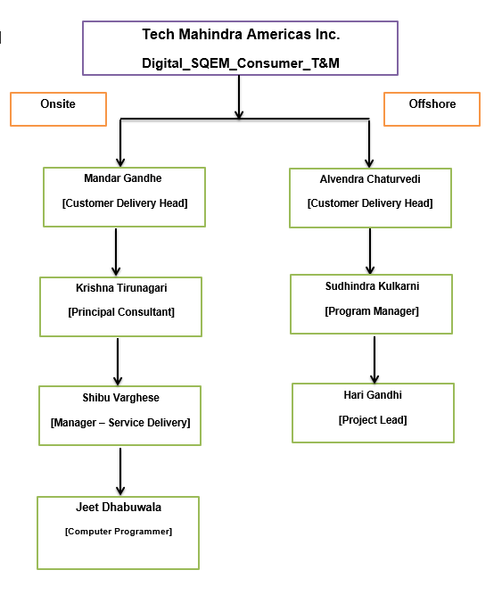

# Tailoring / Deviations

## Tailoring

| **Process requiring Tailor** | **Risks Anticipated by Process Tailoring, If Any** | **Mitigation Plan for Anticipated Risk** |
| --- | --- | --- |
|  | *None* |  |
|  |  |  |

## Deviation

| **Description of Process Deviation** | **Risks Anticipated by Process Deviation, If Any** | **Mitigation Plan for Anticipated Risk** |
| --- | --- | --- |
|  | *None* |  |
|  |  |  |
|  |  |  |

# Interface with Support Groups

Below are the details of the support groups whom the PM can reach for smooth execution of the project. The table below details the group name and their respective responsibilities

| Group | Support Provided | Type of Review | Review Frequency |
| --- | --- | --- | --- |
| Technical Learning Services (TLS) | * Arrange for training requirements for the project |  |  |
| Technical Infrastructure Management (TIM) | * Provide hardware/system software/ operations support for the project * Handle problems related to hardware and other standard software |  |  |
| Resource Management Group (RMG) | * Allocate the manpower with required skills for the project |  |  |
| Corporate Service (CS) | * Provide physical infrastructure in terms of seating etc. |  |  |
| QWAY | * Provide support for BMS implementation in project * Review the Project Plan * Participate in PMRs * Plan internal/ external audits for the project * Provide support for ‘Process Improvement Initiatives’ in a project |  |  |
| Information Security Group (ISG) | * Provide support for implementation of security practices in the project * Help projects in Business Continuity Planning (BCP) and Disaster Recovery (DR) |  |  |
| Finance | * Provide Bid Approval ID/ Quote No / Finance approval at the beginning of the project * Raise invoices based on RUS and Milestone for T&M and FP projects respectively. * Review Proposal / Bid amount, margin and provide approval. |  |  |
| Centre of Excellence (CoE) | * Provide required resources and knowledge for the project |  |  |
| Vertical Solutions | * Understand the project domain and provide consultation |  |  |

# Project Environment

|  |  |  |
| --- | --- | --- |
| **Hardware Environment** | **Software Environment** | **Tools** |
| *The minimum desktop configuration required for supporting are Intel i5, 8GB RAM and 500 GB of hard disk space.* | *The software environment defined here is only the desktop which is required for the usage of team and that comprises of the default software, teal leaf, WebLogic server, HTTP watch, Oracle SQL developer. Access to HVD.* | *PACE -HR* |

| **Phase/Activity** | **Tools** |
| --- | --- |
| Configuration Management | NA |
| Unit testing | NA |
| Build | NA |
| Integration | NA |
| Secure Code Review | NA |
| Test Automation | NA |
| Performance Testing | NA |
| Security Testing | NA |
| Defect Tracking | HP ALM (QC),TDP, JIRA, Share Point, Clarify & AOTS |
| Design | NA |
| Timesheet | PACE-HR |
| PMR / QG / IQA / PHR | QSPACE |
| Risk Management | QSPACE- Risk Management Tool |
| Defect Tracking | JIRA, QC, AOTS, SP, Clarify |
| Design | NA |
| Production session | IDSS Tea leaf |
| Logs Analysis | Splunk |

# Managerial Process

## Risks and Issue Management

### Risks

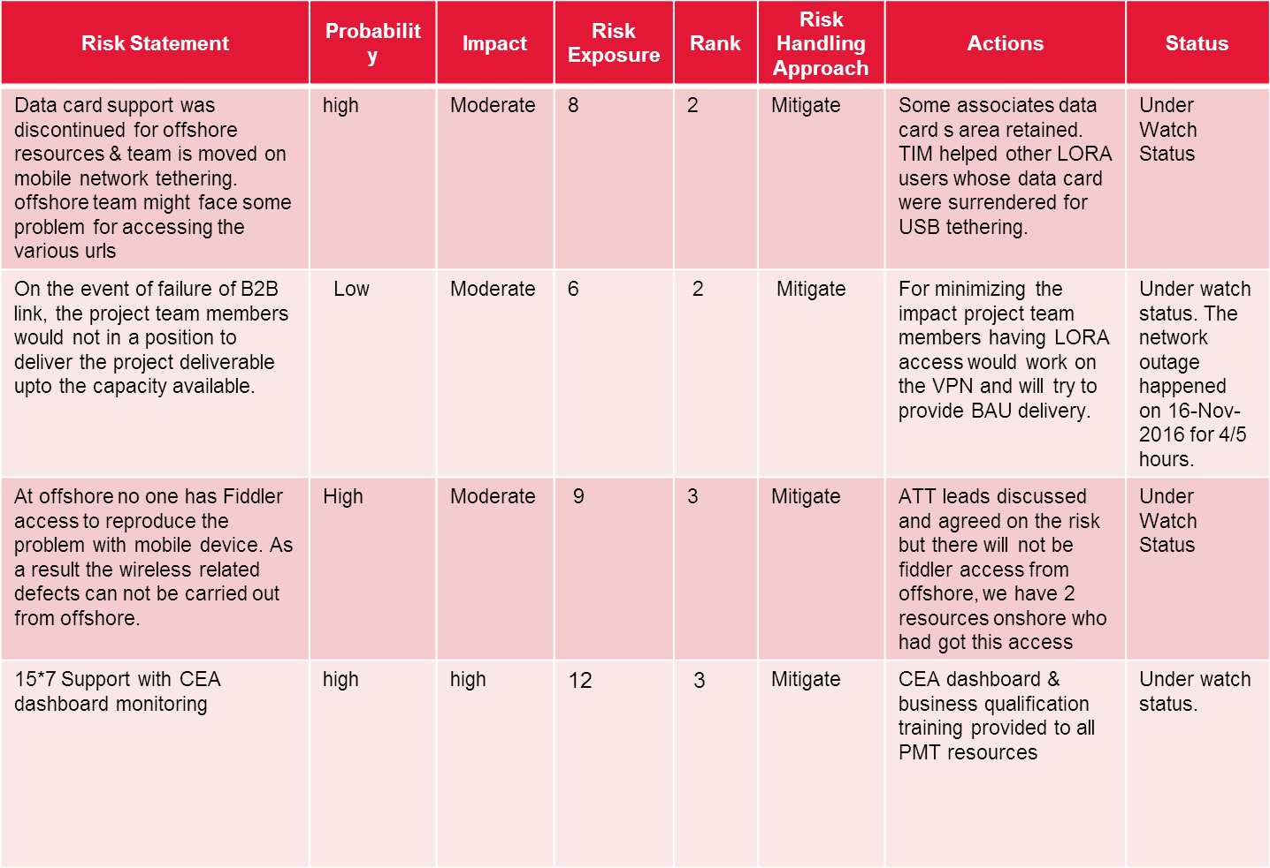

### Opportunities

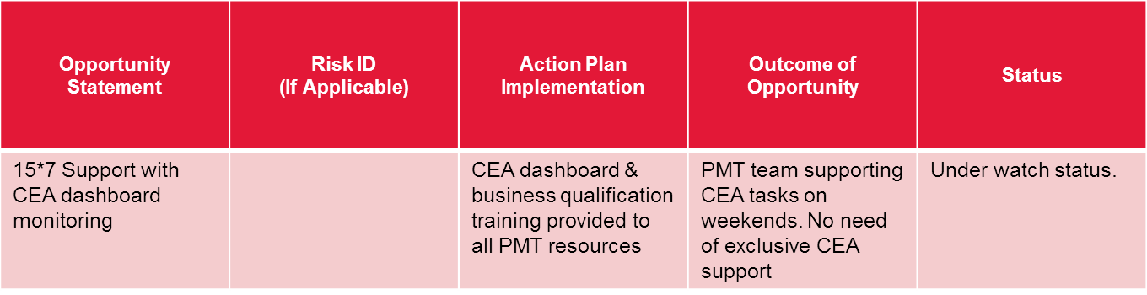

### Issues

* *NA*

*<References/links to issue register may be given here>*

*Guidelines:-*

* *Use the “Issue and Query Register Template (PRJ-TP017)” available in BMS for listing and tracking project issues.*
* *If the PM wants to capture the Risk, Assumptions, Issues and Dependencies in one template then please refer the RAID Register for SI available in BMS>*

.

## Assumptions, Dependencies and Constraints

The team has clear directions on what defects it needs to work on and expectations. The dependencies are in terms of the reporter/PMT providing details on the ticket in details so that it helps us in analysis. The dev team turning around the tickets to fixed in the desired velocity so that the overall backlog gets reduced release on release. The risk register provides the details of the constraints we are currently working on and what it impacts.

## Escalation Plan

The escalation path used by TechM is:

8

Hours

**Team Member/ Team Leader**

**Project Manager**

**Group Head**

**Corporate Head (TechM)**

8

Hours

8

Hours

The escalation path used to escalate issues to customer is:

8

Hours

**Team Member**

**Project Manager**

**Onsite Coordinator/ Account Manager**

**(With Cc to GH) GH/Program Manager)**

**Corporate Head (Customer)**

8

Hours

16

Hours

The escalation path to be used by customer for escalation of issue in TechM is:

8

Hours

**Customer Project**

**Group Head / Project Manager**

**Onsite Coordinator/ Account Manager**

**Corporate Head (TechM)**

8

Hours

16

Hours

## Resource Plan

Project resource requirements are planned and tracked using the Resource Plan. Resource Plan is reviewed half yearly by SPM and required actions are planned and executed.

The updates on forthcoming activities are communicated to SPM and accordingly the resourcing

plans are targeted through mail and F2F communication.

*“Resource Plan Template (PRJ-TP005I)”*

## Training Plan

Project specific trainings are planned and tracked using the Training Plan. Training Plan is reviewed half yearly by PM/SPM and required actions are planned and executed.

Training Guidelines:-

* Training plan for the project should cover training needs identified for team members. This includes all project-training requirements like process, technical, behavioural skills and product quality focus –Application Security, Tools, Domain training
* Each team member inducted for the project shall be provided with an overview of the project, standards in use, tools to be used, project documentation, and project environment.
* A mentor should monitor all on-the-job trainings.
* Use the “Project Training Plan Template” available in BMS to plan and track training requirements for the project.

## Project Tracking and Reporting

### Reviews

|  |  |  |
| --- | --- | --- |
| **Type of Review** | **Participants** | **Frequency of Review** |
| Project Plan Review | PM,PGM, | After any change in Project Plan |
| Metrics Review | QC,PM,PGM, | Monthly |
| IQA | QC, PM, PGM, IBU Head | Quarterly or as decided |
| Project Deliverables (SLA Report) | QC, PM, Team | Covered in IQA |
| PMR | PM, PGM, IBU | Once in Quarter |
| Risk Management | PM, PGM,IBU, QCs | If the Risk exposure of the Risks have been changed drastically |

### Project Status Reporting

| **S. No.** | **Mechanism / Report** | **Recipient** | **Frequency** | **Remarks** |
| --- | --- | --- | --- | --- |
| 1 | Project Health Report (Red Amber Green Report) using QSPACE | Program Manager and Above | Weekly | Mandatory |
| 2 | Resource Utilization Sheet (RUS) | Finance | Monthly |  |
| 3 | Metrics Analysis | Program Manager, PM, QWAY | Monthly/Phase End/ Delivery of Major Work Package | Mandatory |
| 4 | PMR | Program Manager/Program Manager, Peer Program Manager/Program Manager & QWAY Representative | Once in 90 days | Mandatory |
| 5 | IQA | Program Manager/Program Manager, Peer Program Manager/Program Manager & QWAY Representative | Once in 90 Days | Mandatory |
| 6 | Customer Feedback | Program Manager, Peer Program Manager & QWAY Representative | Six Monthly | Mandatory |

### Defect Prevention

*NA*

# Quality management Plan

## Plan Measures

| S. No. | Data | Data Source | When | Responsibility for Data Collection |
| --- | --- | --- | --- | --- |
| 1 | No. of defects analyzed by PMT team | JIRA/HP ALM/AOTS/SP | Quarterly | PM/Leads |
| 2 | No. Of defects returned by Dev to PMT | QC/JIRA/Mails | Ongoing | PM/Leads |

## Project Goals

| **Project Goals for Quality and Process Performance** | **Metric(s)** | | **Unit of Measure** | **Specification Limits** | | | **Remarks** |
| --- | --- | --- | --- | --- | --- | --- | --- |
| **Target** | **USL** | **LSL** |
| Maintain Capacity Utilization in the range of 80-100% | Capacity Utilization | | % | 90 | 95 | 86 | Sustainable goal, Current Capacity utilization is approx. 90% |
| Time sheet reporting in EBS-H | Time Spent | | % | 100 | 100 | 100 | Current timesheet reporting is 90% on monthly basis |
| SLA Adherence | | Time for Response | % | 100 | 100 | 95 | Source: SOW  SLA Reports generated from project CSL data. |

## Plan For Meeting Project Goals – High Maturity Practice

We will Track and monitor the identified goals as of now.

**<Mention the goals identified X1, X2>**

## Tracking and Analysis

The project performance would be monitored on monthly basis to determine whether the project’s goals will be satisfied, and corrective action are identified (if needed).

* Metric(s) would be collected and analysed at unit of planning
* Special causes of variations are identified, analysed and corrective/preventive actions taken as appropriate.
* The Metrics Analysis report is prepared using the “Metric Analysis Sheet for Maintenance and Operations Support Projects (ITS-E-T061B)”,
* SLAs are being tracked by Customer on monthly basis.

## Operating metrics

On a monthly basis following operating metrics need to be tracked:

|  |  |  |
| --- | --- | --- |
| **Metric(s)** | **Definition** | **Remarks** |
| *Onsite Subcon Index%* | *(# of Onsite sub-contractors / Total no. of onsite Associates)*100* |  |
| *Offshoring Index %* | *(No. of Offshore billed associates) / (Total billed associates + onsite non-billed associates)*100* | *Here total billed associates implies (offshore + onsite)* |
| *Leakage Index %* | *(No. of Onsite unbilled associates/ total no. of Onsite Associates)*100* | *Here total onsite strength includes billed + unbilled associates* |
| *Utilization Index %* | *(Billed efforts /Available efforts) *100* | *Available efforts include billed +unbilled efforts* |
| *Tail Index %* | *(# of Tail Band associates/ Total no. of associates)*100* | *Tail band comprises of U1, U2, and U3 band associates.* |

# Customer Supplied Processes

* NA

# Configuration Management Plan (CMP)



< Needs to be completed –Right Now this has been placed as a place holder>

# Asset Management and Business CONTINUITY PLAN



BCP plan is maintained in the ISG Dash Board.

# Supplier Management Plan



# Operational Process



# Updates to PRoject Plan

PROJECT PLAN and the other related plans will be updated in following circumstances:

* When the project activities are not being carried out as per the plan and corrective action needs to be taken
* Change in the scope of the work and other commitments
* To incorporate any high risk findings
* To incorporate intermediate closure findings
* To incorporate SQA Review or audit findings
* To change the Project’s operational process based on the defect prevention measures / process improvements introduced
* <Include other factors that may be relevant for the project.>

The Project Plan document will be updated only on ‘major’ events as defined above. The minor changes are collated in an excel sheet until they are updated in this main plan.

# Glossary

|  |  |
| --- | --- |
| Abbreviation | Definition |
| BCP | Business Continuity Plan |
| BMS | Business Management System |
| DR | Disaster Recovery |
| FTE | Full Time Employee |
| PGM | Program Manager |
| PL | Project Leader |
| PM | Project Manager |
| PMR | Project Management Review |
| PP | Project Plan |
| QWAY | Quality Management Group |
| SLN | Service Level Norm |
| SOW | Statement of Work |
| SQA | Software Quality Analyst |
| TechM | Tech Mahindra |
| VV&T | Verification, Validation, and Testing |
| DP | Defect Prevention |

*<Please update the table with the definition of all abbreviations /acronyms used in the document.>*

# Annexure A – Roles and Responsibilities

| Role | Responsibilities |
| --- | --- |
| Customer Representative / Client Partner | * Approve contractual documents such as SOW, Quote, Service Catalogue, or Task Order * Resolution of customer related issues * Review project status * Answer project queries and issues on time * Arrange timely delivery of project receivables * Provide timely Sign off on project deliverables * Arrange adequate access rights to customer environment for project team members |
| Delivery Manager | * Ensure seamless delivery of projects. * Ensure that projects have required number of resources and they are adequately trained. * Ensure that projects are achieving desired level of customer satisfaction. * Ensure that projects are maintaining process quality by adhering to BMS processes. * Participate in Pre-sales related activities. |
| Program Manager/ Offshore Delivery Manager | * Review and approve Project Plan (PP) * Review project status * Ensure customer satisfaction & Build a long term relationship with customer * Resolve project issues * Ensure project execution profitability * Approve contractual Deliveries * Ensure project execution as per Business Management System (BMS) * Conduct Project Management Review (PMR) meetings * Ensure coordination and integration of onsite and offshore teams |
| Customer Delivery Manager (CDM) | * Customer Relationship Management (CRM) * Following invoicing * Participate in Project Review meetings |
| Onsite Coordinator | * Help in liaison with customer * Ensure timely delivery of receivables * Arrange required training for onsite team members * Obtain acceptance of deliverables * Ensure that TechM BMS is followed by the onsite project team |
| Project Manager (PM) | * Prepare and maintain Project Plan * Execute project as per TechM BMS and approved PP * Ensure that a copy of SOW/Contract/Letter of Intent (LOI)/Task Order and Commitment Review form is available. * Review or ensure review of project receivables * Perform proactive risk management * Establish the project organization and provide technical induction to all team members covering a brief profile of the customer * Ensure that the resources are managed effectively and efficiently * Arrange for additional training, if requisite skills are not available * Monitor and report on project progress to management using status reports and PMR meetings * Resolve or escalate all issues as per escalation plan * Ensure acceptance of deliverables from the customer * Manage and facilitate communication related to the project with customer * Manage expectations of project team members and customer * Liaise with support groups * Submit project metrics to Quality Management Group (QWAY) * Participate in Audit Review meetings * To plan and review for Product Quality activities |
| Project Leader (PL) | * Induct team members to the project * Review receivables * Identify and collate customer requirements * Schedule and monitor the task assignment to the team * Prepare project deliverables * Conduct team meetings * Participate in project review meetings and audits * Follow and demonstrate implementation as per BMS and PP * Approve test plans and source code * Identification of DP Team * Identification of strategy / actions * Monitoring DP goals * Ensure DP meetings are happening as planned * Identifying what are the critical products requirements that need product check. |
| Project Team Members | * Study and understand the planning documents * Carryout assigned technical tasks as per the project schedule * Participate in peer reviews * Report progress/problems to PM or PL * Help fellow team members on technical issues * Follow BMS processes * Project team to use guidelines on Application security |
| Software Quality Analyst (SQA) | * Review critical work products as identified in PP * Carry out final inspection * Carry out physical configuration audits * Participate in relevant project meetings * Report project’s status and findings of SQA activities to Program Manager |
| Quality Consultant (QC) | * Perform process SQA * Facilitate project in implementing and improving processes * Ensure conduct of Internal audit |

# document history

| **Version** | **Date** | **Author (function)** | **Reviewed by** | **Approved by** | **Nature of changes** |
| --- | --- | --- | --- | --- | --- |
| Issue 1.0 | 08-Mar-13 | Renuka Bhatia | Amrut Mulay, Shini Srivastava, Usha Kadaa | Anil Sane | TechM- MSAT integration issue |
| Issue 1.1 | 7-June-2013 | Itika Sharma | Usha Kadaba, Shini Srivastava | Thenmozhi Sengodan | Reference ID’s are changed and FTE full form is changed to Full Time Employee |
| Issue 1.2 | 19-July-2013 | Itika Sharma | Usha Kadaba, Shini Srivastava | Thenmozhi Sengodan | Ported to new template post-merger |
| Issue 1.3 | 7-Nov-2013 | Sonu Jain, Nidhi Saxena | Usha Kadaba, Shini Srivastava | Thenmozhi Sengodan | Application security |
| Issue 1.4 | 7-Jan-2014 | Shini Srivastava | Nidhi Saxena | Thenmozhi Sengodan | Product Quality : Vertical Solutions |
| Issue 2.0 | 19-Aug-14 | Santoshanand Adkar,  Sandeep Sapre | Anil Sane, Charan S, Kiran Kumar Rao, Rajendra Medhi, Arun K, Asmita Parab,  Vijayarekka,  Ashwini Chaudhari,  Amitabh Shanker,  Saravanan R | Amitabh Shanker | Template is revamped to incorporate CMMI PIP changes pertaining to PMP enhancements.  Added changes related to TK9K audit findings  Incorporated the review changes related to R&R, Operational Plan.  Revamped the QPM section as per review comments received |
| Issue 2.1 | 23-Aug-15 | Mangesh Sawant | Ashwini Chaudhari | Amitabh Shanker | * Introduced Operating metrics in clause 7.3 * Frequency of PMR/QMR updated as per project criticality |